Lab 10

Configuring VPN And Routing

This lab contains the following exercises and activities:

|  |  |
| --- | --- |
| Exercise 10.1 | Installing and Configuring RRAS |
| Exercise 10.2 | Configuring a VPN Server |
| Exercise 10.3 | Configuring a VPN Client |
| Exercise 10.4 | Configuring Split Tunneling |
| Exercise 10.5 | Configuring Routing |
| Exercise 10.6 | Resetting Servers |
| Lab Challenge | Using the Route Command |

BEFORE YOU BEGIN

The lab environment consists of student workstations connected to a local area network, along with a server that functions as the domain controller for a domain called *contoso.com*. The computers required for this lab are listed in Table 10-1.

Table 10-1

Computers Required for Lab 10

|  |  |  |
| --- | --- | --- |
| Computer | Operating System | Computer Name |
| Server (VM 1) | Windows Server 2012 | RWDC01 |
| Server (VM 2) | Windows Server 2012 | Server01 |
| Server (VM 3) | Windows Server 2012 | Server02 |

In addition to the computers, you also require the software listed in Table 10-2 to complete Lab 10.

Table 10-2

Software Required for Lab 10

|  |  |
| --- | --- |
| Software | Location |
| Lab 10 student worksheet | Lab10_worksheet.rtf (provided by instructor) |

Working with Lab Worksheets

Each lab in this manual requires that you answer questions, take screen shots, and perform other activities that you will document in a worksheet named for the lab, such as Lab10_worksheet.rtf. You will find these worksheets on the book companion site. It is recommended that you use a USB flash drive to store your worksheets, so you can submit them to your instructor for review. As you perform the exercises in each lab, open the appropriate worksheet file using WordPad, fill in the required information, and save the file to your flash drive.

After completing this lab, you will be able to:

* Install and configure Remote Access Role
* Configure VPN settings
* Configure routing

Estimated lab time: 125 minutes

|  |  |
| --- | --- |
| Exercise 10.1 | Installing and Configuring RRAS |
| Overview | To configure standard VPN connections, you use Routing and Remote Access Server. You install Routing and Remote Access Server on Server01. |
| Completion time | 15 minutes |

**Mindset Question: During this lab, you install and configure Routing and Remote Access Server. What are all of the functions that the Routing and Remote Access Server can perform?**

**1.** Log in to Server01 as the **Contoso\administrator** user account. The Server Manager console opens.

**2.** On Server Manager, click Manage and click Add Roles and Features. The Add Roles and Feature Wizard opens.

**3.** On the Before you begin page, click Next.

**4.** Select *Role-based or feature-based installation* and then click Next.

**5.** On the Select destination server page, click Next.

**6.** Scroll down and select Remote Access.

**7.** When the Add Roles and Features Wizard dialog box opens, click Add Features.

**8.** Back on the Select server roles page, click Next. On the Select features page, click Next.

**9.** On the Remote Access page, click Next. On the Select role services page, keep DirectAccess and VPN (RAS) selected and select Routing. Click Next.

**10.** On the Confirm installation selections page, click Install.

**11.** When the installation is complete, click Close.

End of exercise. You can leave the windows open for the next exercise.

|  |  |
| --- | --- |
| Exercise 10.2 | Configuring a VPN Server |
| Overview | Server01 will be the primary application server, which will be used for most applications. |
| Completion time | 30 minutes |

**Mindset Question: Routing and Remote Access Server supports VPN connections. What are the types of VPN connections that are supported by Routing and Remote Access Server?**

**1.** On Server01, on the Task bar, right-click the Network and Sharing Center icon and click Open Network and Sharing Center.

**2.** Click Change adapter settings.

**3.** Right-click Ethernet and click Rename. Change the name to Internal and press the Enter key.

**4.** Right-click Ethernet 2 and click Rename. Change the name to External and press the Enterkey. When done, the Network Connections should look similar to Figure 10-1.

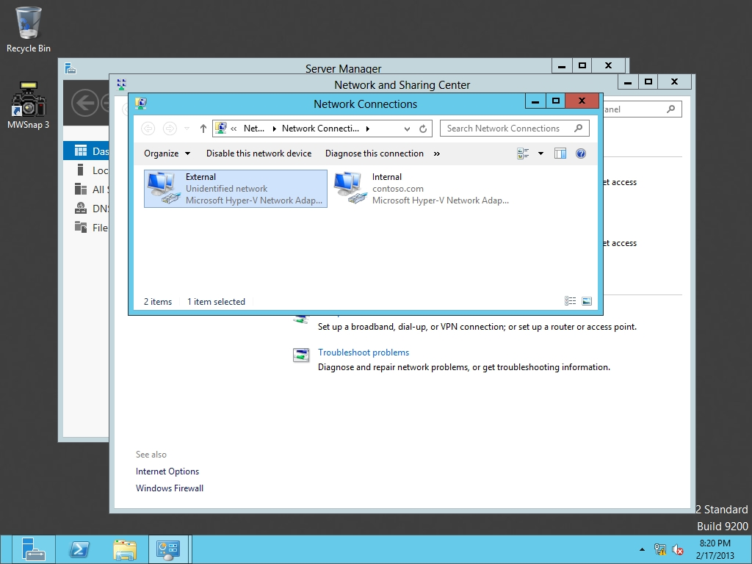

Figure 10-1

Viewing network connections

**5.** Right-click External and click Properties.

**6.** When the External Properties dialog box opens, double-click *Internet Protocol Version 4 (TCP/IPv4)*.

**7.** Click Use the following options and specify the following:

IP address: **192.168.2.1**

Subnet mask: **255.255.255.0**

Click OK. If it says the DNS server list is empty, click OK.

**8.** Click OK to close the External Properties dialog box.

**9.** Close Network Connections.

**10.** On Server01, Server Manager, click Tools > Routing and Remote Access. The Routing and Remote Access console opens as shown in Figure 10-2.

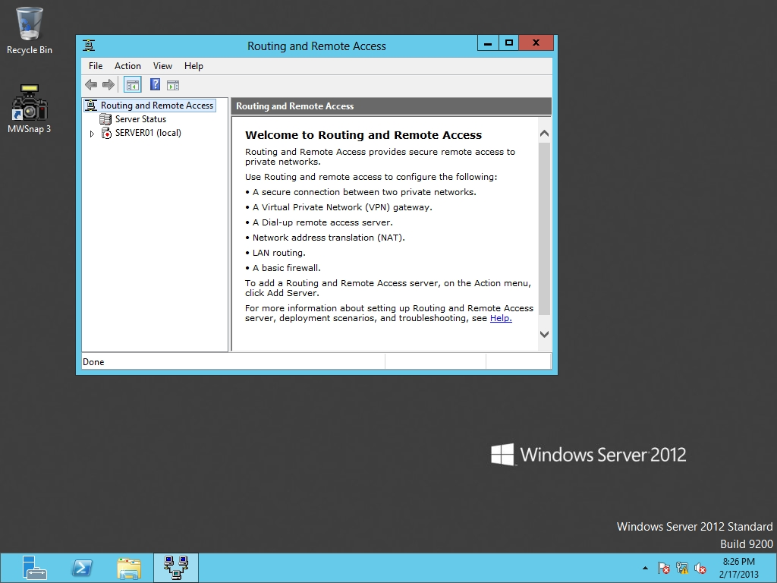

Figure 10-2

Opening the Routing and Remote Access console

**11.** Right-click Server01 and select *Configure and Enable Routing and Remote Access*. The Routing and Remote Access Server Setup Wizard opens.

**12.** On the Welcome page, click Next.

**13.** On the Configuration page, select *Virtual private network (VPN) access and NAT* (as shown in Figure 10-3) and click Next.

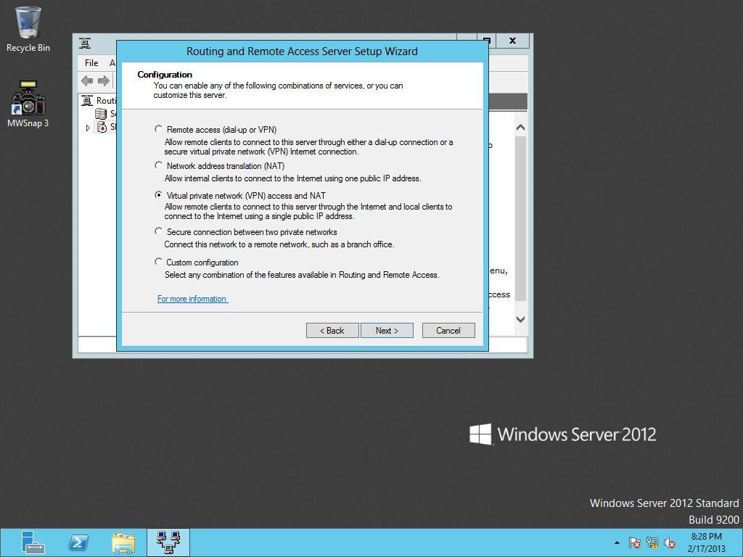

Figure 10-3

Specifying the Routing and Remote Access configuration

**14.** On the VPN Connection page, select External and click Next.

**15.** On the IP Address Assignment page, click *From a specified range of addresses* and click Next.

**16.** On the Address Range Assignment page, click New.

**17.** When the New IPv4 Address Range dialog box opens, specify the Start IP address as **192.168.1.40** and the End IP address as **192.168.1.45**. Click OK.

**18.** Back on the Address Range Assignment page, click Next.

**19.** On the *Managing Multiple Remote Access Servers* page, click Next.

**20.** On the Completing the Routing and Remote Access Server Setup Wizard page, click Finish.

**21.** When prompted to open a port of Routing and Remote access in the Windows Firewall, click OK.

**22.** When it asks to support the relaying of DHCP messages from remote access clients message, click OK.

**23.** Take a screen shot of the Routing and Remote Access window by pressing Alt+Prt Scr and then paste it into your Lab10_worksheet file in the page provided by pressing Ctrl+V.

**24.** After RRAS starts, click the Start button, and click Administrative Tools. When theAdministrative Tools opens, double-click *Windows Firewall with Advanced Security*.

**25.** When Windows Firewall with Advanced Security opens, under Actions, click Properties.

**26.** When the *Windows Firewall with Advanced Security on Local Computer* dialog box opens, change the Firewall state to Off.

**27.** Change the Firewall state to Off in the Private profile and Public Profile tabs.

**28.** Click OKto close the *Windows Firewall with Advanced Security on Local Computer* dialog box.

**29.** Close *Windows Firewall with Advanced Security* and *Administrative Tools*.

**30.** Right-click Server01 in Routing and Remote Access, and click Properties.

|  |  |
| --- | --- |
| Question 1 | Which tab would you use to specify a preshared key for RRAS? |

|  |  |
| --- | --- |
| Question 2 | Which VPN method requires a digital ceritificate to provide a SSL connection? |

**31.** Click OK to close the Server01 (local) Properties dialog box.

**32.** Right-click Ports and click Properties. The Ports Properties dialog box opens.

|  |  |
| --- | --- |
| Question 3 | By default, how many IKEv2 connections are available? |

**33.** Click OK to close the Ports Properties dialog box.

**34.** Log on to RWDC01 as Contoso\**administrator**.

**35.** On Server Manager, from Tools, click *Active Directory Users and Computers*.

**36.** Expand contoso.com, if needed, and then click Users.

**37.** Double-click the Administrator account. The Administrator Properties dialog box opens.

**38.** Click the Dial-in tab.

|  |  |
| --- | --- |
| Question 4 | What is the default setting for Network Access Permission? |

**39.** In the Network Access Permission section, click to select Allow access, as shown in Figure 10-4.

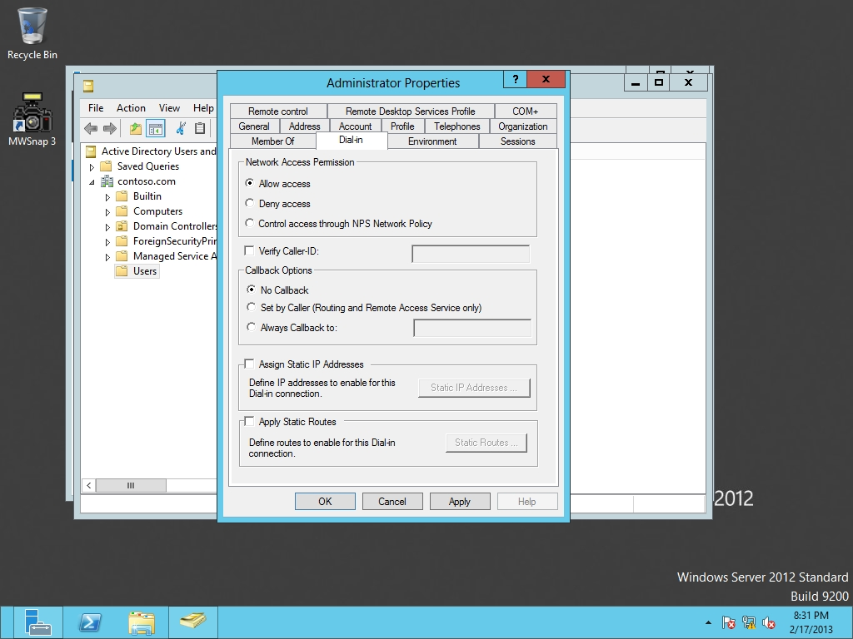

Figure 10-4

Allowing access to Dial-in for Administrator

**40.** Click OK to close the Administrator Properties dialog box.

**41.** Close Active Directory Users and Computers.

End of exercise. You can leave the windows open for the next exercise.

|  |  |
| --- | --- |
| Exercise 10.3 | Configuring a VPN Client |
| Overview | Now that you have configured the VPN server, you need to configure a client to connect to the VPN server. During this exercise, you use Server02 to act as a VPN client. |
| Completion time | 30 minutes |

**1.** Log in to Server02 as the **Contoso\Administrator** user account. The Server Manager console opens.

**2.** On Server02, on the Taskbar, right-click Network and Sharing Center icon and click Open Network and Sharing Center.

**3.** Click Change adapter settings.

**4.** Right-click Ethernet and click Disable.

**5.** Right-click Ethernet2 and click Properties.

**6.** When the Ethernet Properties dialog box opens, double-click *Internet Protocol Version 4 (TCP/IPv4)*.

**7.** Click Use the following options and specify the following:

IP address: **192.168.2.10**

Subnet mask: **255.255.255.0**

Click OK.

**8.** Click OK to close the Ethernet 2 Properties dialog box.

**9.** Go back to Network and Sharing Center, and choose *Set up a new connection or network*.

**10.** On the Set Up a Connection or Network page, choose Connect to a workplace. Click Next.

**11.** On the Connect to a Workplace page, click Use my Internet connection.

**12.** If it asks if you want to set up Internet connection, click *I’ll set up an Internet connection later*.

**13.** When it asks you to type the Internet address to connect to, type **192.168.2.1** in the Internet address text box. Click Create.

**14.** When the Networks pane appears (as shown in Figure 10-5), click VPN Connection and click Connect.

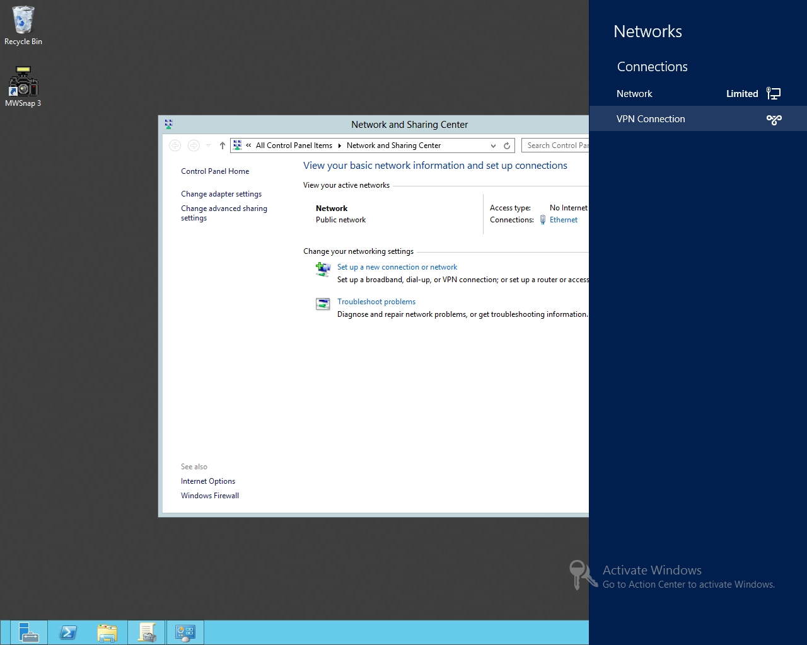

Figure 10-5

Clicking VPN Connection

**15.** For the user name and password, use **Contoso\Administrator** and **Password01**. Click OK.

**16.** Take a screen shot of the Networks pane showing a successful connection by pressing Alt+Prt Scr and then paste it into your Lab10_worksheet file in the page provided by pressing Ctrl+V.

**17.** Click the VPN Connection and click Disconnect.

**18.** Click the Desktop.

**19.** On RWDC01, using Active Directory Users and Computers, double-click the Administrator account.

**20.** When the Administrator Properties dialog box opens, click the Dial-in tab.

**21.** In the Network Access Permission section, click Control access through NPS Network Policy.

**22.** Click OK to close the Administrator Properties dialog box.

**23.** On Server02, click the Network and Sharing Center icon on the taskbar, click VPN Connection and click Connect.

|  |  |
| --- | --- |
| Question 5 | What error message did you get? |

**24.** Click Close and click the Desktop.

**25.** On RWDC01, using Active Directory Users and Computers, double-click the Administrator account.

**26.** When the Administrator Properties dialog box opens, click the Dial-in tab.

**27.** In the Network Access Permission section, click Allow access.

**28.** Click OK to close the Administrator Properties dialog box.

**29.** On Server01, open the Administrative Tools and double-click Windows Firewall with Advanced Security.

**30.** When the Windows Firewall with Advanced Security console opens, click Properties under Actions.

**31.** On the Domain Profile tab, change the Firewall state to On.

**32.** Using the Private Profile and Public Profile tabs, turn the Firewall state to On.

**33.** Click OK to close the Windows Firewall with Advanced Security console.

**34.** On Server02, click the Network and Sharing Center icon on the taskbar.

**35.** Click VPN Connection and click Connect.

|  |  |
| --- | --- |
| Question 6 | What error message did you get? |

**36.** Click Close and click the Desktop.

**37.** On Server01, using Windows Firewall with Advanced Security, click Properties under Actions.

**38.** On the Domain Profile tab, change the Firewall state to Off.

**39.** Using the Private Profile and Public Profile tabs, turn the Firewall state to Off.

**40.** Click OK to close the Windows Firewall with Advanced Security console.

|  |  |
| --- | --- |
| Question 7 | Besides using the built-in networking tools found in Windows, what can you use to create an executable that will automatically create a VPN client to connect to a particular server or address? |

End of exercise. You can leave the windows open for the next exercise.

|  |  |
| --- | --- |
| Exercise 10.4 | Configuring Split Tunneling |
| Overview | During this exercise, you take the current VPN connection that you created in Exercise 10.3, and enable split tunneling, so that corporate traffic will go through the Internet and Internet traffic will go out the local Internet connection. |
| Completion time | 5 minutes |

**Mindset Question: During this exercise, you configure split tunneling. Why is split tunneling not recommended for corporate networks?**

**1.** On Server02, click the Network and Sharing Center icon on the Task bar. When the Networks pane opens, right-click VPN Connection and click View connection properties. The VPN Connection Properties dialog box opens.

**2.** Click the Networking tab.

**3.** Double-click the Internet Protocol Version 4 (TCP/IPv4).

**4.** On the Internet Protocol Version 4 (TCP/IPv4) Properties dialog box, click the Advanced button.

**5.** On the Advanced TCP/IP Settings dialog box, on the IP Settings tab, deselect the *Use default gateway on remote network*.

**6.** Take a screen shot of the Advanced TCP/IP Settings dialog box by pressing Alt+Prt Scr and then paste it into your Lab10_worksheet file in the page provided by pressing Ctrl+V.

**7.** Click OK to close the Advanced TCP/IP Settings dialog box.

**8.** Click OK to close the Internet Protocol Version 4 (TCP/IPv4) Properties dialog box.

**9.** Click OK to close the VPN Connection Properties dialog box.

End of exercise. You can leave the windows open for the next exercise.

|  |  |
| --- | --- |
| Exercise 10.5 | Configuring Routing |
| Overview | During this exercise, you configure one of the more basic routing protocols to Server01. |
| Completion time | 20 minutes |

**Mindset Question: So far, you have built a simple network architecture that consists of two subnets connected together with Server01. If you had additional subnets, what simple routing protocol in Windows Server 2012 can you choose that takes little configuration and what are the limits of this routing protocol?**

**1.** On Server02, right-click the Network and Sharing Center icon on the taskbar, and click Open Network and Sharing Center.

**2.** When the Network and Sharing Center opens, click Change adapter settings and double-click Ethernet 2.

**3.** When the Ethernet 2 Status dialog box opens, click Properties.

**4.** When the Ethernet 2 Properties dialog box opens, double-click Internet Protocol Version 4 (TCP/IPv4).

**5.** In the Internet Protocol Version 4 (TCP/IPv4) Properties dialog box, configure the Default gateway to 192.168.2.1.

**6.** Click OK to close the Internet Protocol Version 4 (TCP/IPv4) Properties dialog box.

**7.** Click OK to close the Ethernet 2 Properties dialog box.

**8.** Click Close to close the Ethernet 2 Status dialog box.

**9.** Open a command prompt and try to ping 192.168.1.60.

|  |  |
| --- | --- |
| Question 8 | Did the ping succeed? |

**10.** On Server01, using Routing and Remote Access, right-click Server01 and click Disable Routing and Remote Access.

**11.** When you are prompted to continue, click Yes. It will take a couple minutes to stop Routing and Remote Access.

**12.** Right-click Server01, and click Configure and Enable Routing and Remote Access.

**13.** When the Routing and Remote Access Server Setup Wizard starts, click Next.

**14.** On the Configuration page, click Custom configuration and click Next.

**15.** On the Custom Configuration page, click to select LAN routing and click Next.

**16.** When the wizard is complete, click Finish.

**17.** When the Routing and Remote Access dialog box opens, click Start service.

**18.** Expand the IPv4 node. Then right-click General under IPv4 and click New Routing Protocol.

**19.** When the New Routing Protocol dialog box opens (as shown in Figure 10-6), click *RIP Version2 for Internet Protocol* and and click OK.

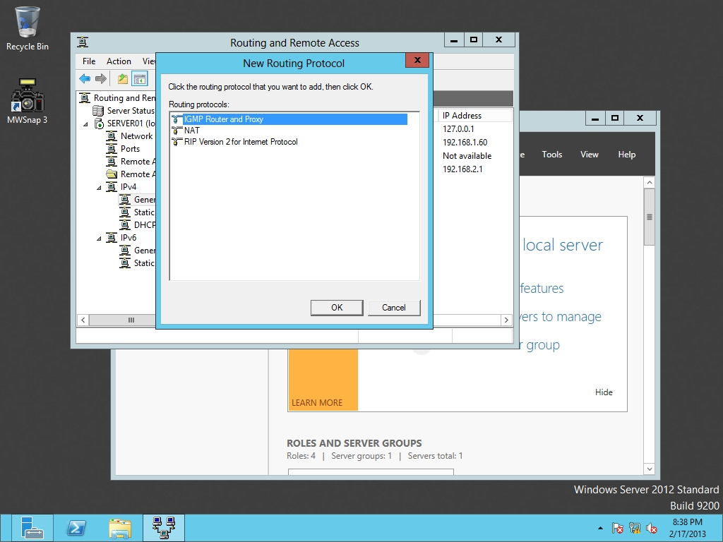

Figure 10-6

Adding a new routing protocol

**20.** Right-click RIP and click New Interface.

**21.** Click External and click OK.

**22.** When the RIP Properties – External Properties dialog box opens, click OK.

**23.** Right-click RIP and click New Interface.

**24.** Click Internal and click OK.

**25.** When the RIP Properties – Internal Properties dialog box opens, click OK.

**26.** On Server02, using the command prompt, execute the following command:

**Ping 192.168.1.60**

|  |  |
| --- | --- |
| Question 9 | Did the ping succeed? |

End of exercise. You can leave the windows open for the next exercise.

|  |  |
| --- | --- |
| Exercise 10.6 | Resetting Servers |
| Overview | Before you can continue to the next exercise, you need to disable Routing and Remote Access. |
| Completion time | 5 minutes |

**1.** On Server01, with Routing and Remote Access, right-click Server01 and click Disable Routing and Remote Access.

**2.** When you are prompted to continue, click Yes.

**3.** After RRAS stops, close Routing and Remote Access.

**4.** On Server02, open Network and Sharing Center, if needed.

**5.** Click Change adapter settings.

**6.** Right-click Ethernet and click Enable.

**7.** Close *Network Connections and Network and Sharing Center*.

Lab REview Questions

|  |  |
| --- | --- |
| **Completion time** | **10 minutes** |

**1.** In Exercise 10.2, what software included with Windows Server 2012 allows you to create a VPN server used with PPTP and L2TP?

**2.** In Exercise 10.2, what program did you use to allow the Administrator to connect using RRAS?

**3.** In Exercise 10.3, where do you define VPN connections in Windows Server 2012 when a server needs to act as a VPN client?

**4.** In Exercise 10.4, which option was used to enable or disable split tunneling?

**5.** In Exercise 10.5, what version of RIP does Windows Server 2012 support?

|  |  |
| --- | --- |
| Lab Challenge | Using the Route Command |
| Overview | To complete this challenge, you will demonstrate how to use the Route command. |
| Completion time | 10 minutes |

By default, routes are automatically created within Windows. However, you can create static routes by using the route.exe command. Therefore, specify the commands that you would use to perform the following tasks?

**1.** What command would you to display the routing table in Windows?

**2.** What command would you to create a route to the 172.25.1.x (mask 255.255.255.0) that goes out the 192.168.1.20 router?

**3.** What option makes a static router permanent so that the route will remain after a computer is rebooted?

**4.** What command would use to delete the route defined in Question 2?

End of lab. You can log off or start a different lab. If you want to restart this lab, you’ll need to click the End Lab button in order for the lab to be reset.